**Quarterly Report – Public Page**

**Date of Report:** 5th Quarterly Report - *January 23, 2024*

**Contract Number:** *693JK32210015POTA*

**Prepared for:** *DOT-PHMSA*

**Project Title:** *Dynamic Geohazard Risk and Decision Support Platform*

**Prepared by:**  *Boston Geospatial, Inc.*

**Contact Information:**  *Justin Oliveira,* [*justin@bostongeospatial.com*](mailto:justin@bostongeospatial.com)*, 321-720-3568*

**For quarterly period ending:** *December 31, 2023*

**1: Items Completed During this Quarterly Period:**

A detailed overview of the progress this past quarter is provided in the various sections below.

| ***Item #*** | ***Task #*** | ***Activity/Deliverable*** | ***Title*** |
| --- | --- | --- | --- |
| 11 | 5.2 | Cost Estimation Module | Research and create replacement/triage cost estimation framework; Cost estimation report generator module development |
| 16 | 5.3 | Cost Estimation Module | Develop costing API for rehab/replace/triage; Initialize storage database for client recommendation reports |
| 17 | 5.4 | Cost Estimation Module | Submit Costing API and Methodology Documentation |
| 19 | 0.1 | 5th Quarterly Status Report | Submit 5th quarterly report |

**2: Items Not-Completed During this Quarterly Period:**

| ***Item #*** | ***Task #*** | ***Activity/Deliverable*** | ***Title*** |
| --- | --- | --- | --- |
| 13 | 3.2 | Geohazards Module | Post-process InSAR measurements for TAP operators assetbase into geodatabase; Develop API wrapper for geohazard geodatabases |
| 14 | 3.3 | Geohazards Module | Submit Geohazards API and Methodology Documentation |
| 15 | 4.1 | Load Case Module | Develop library to extract prior seismic event load case boundary conditions (acceleration loads) and ground kinematics conditions (subsidence loads) |
| 18 | 6.1 | GIS Interface | ArcGIS interface initialization, geodatabase connections, and dashboard setup |

**3: Project Financial Tracking During this Quarterly Period:**

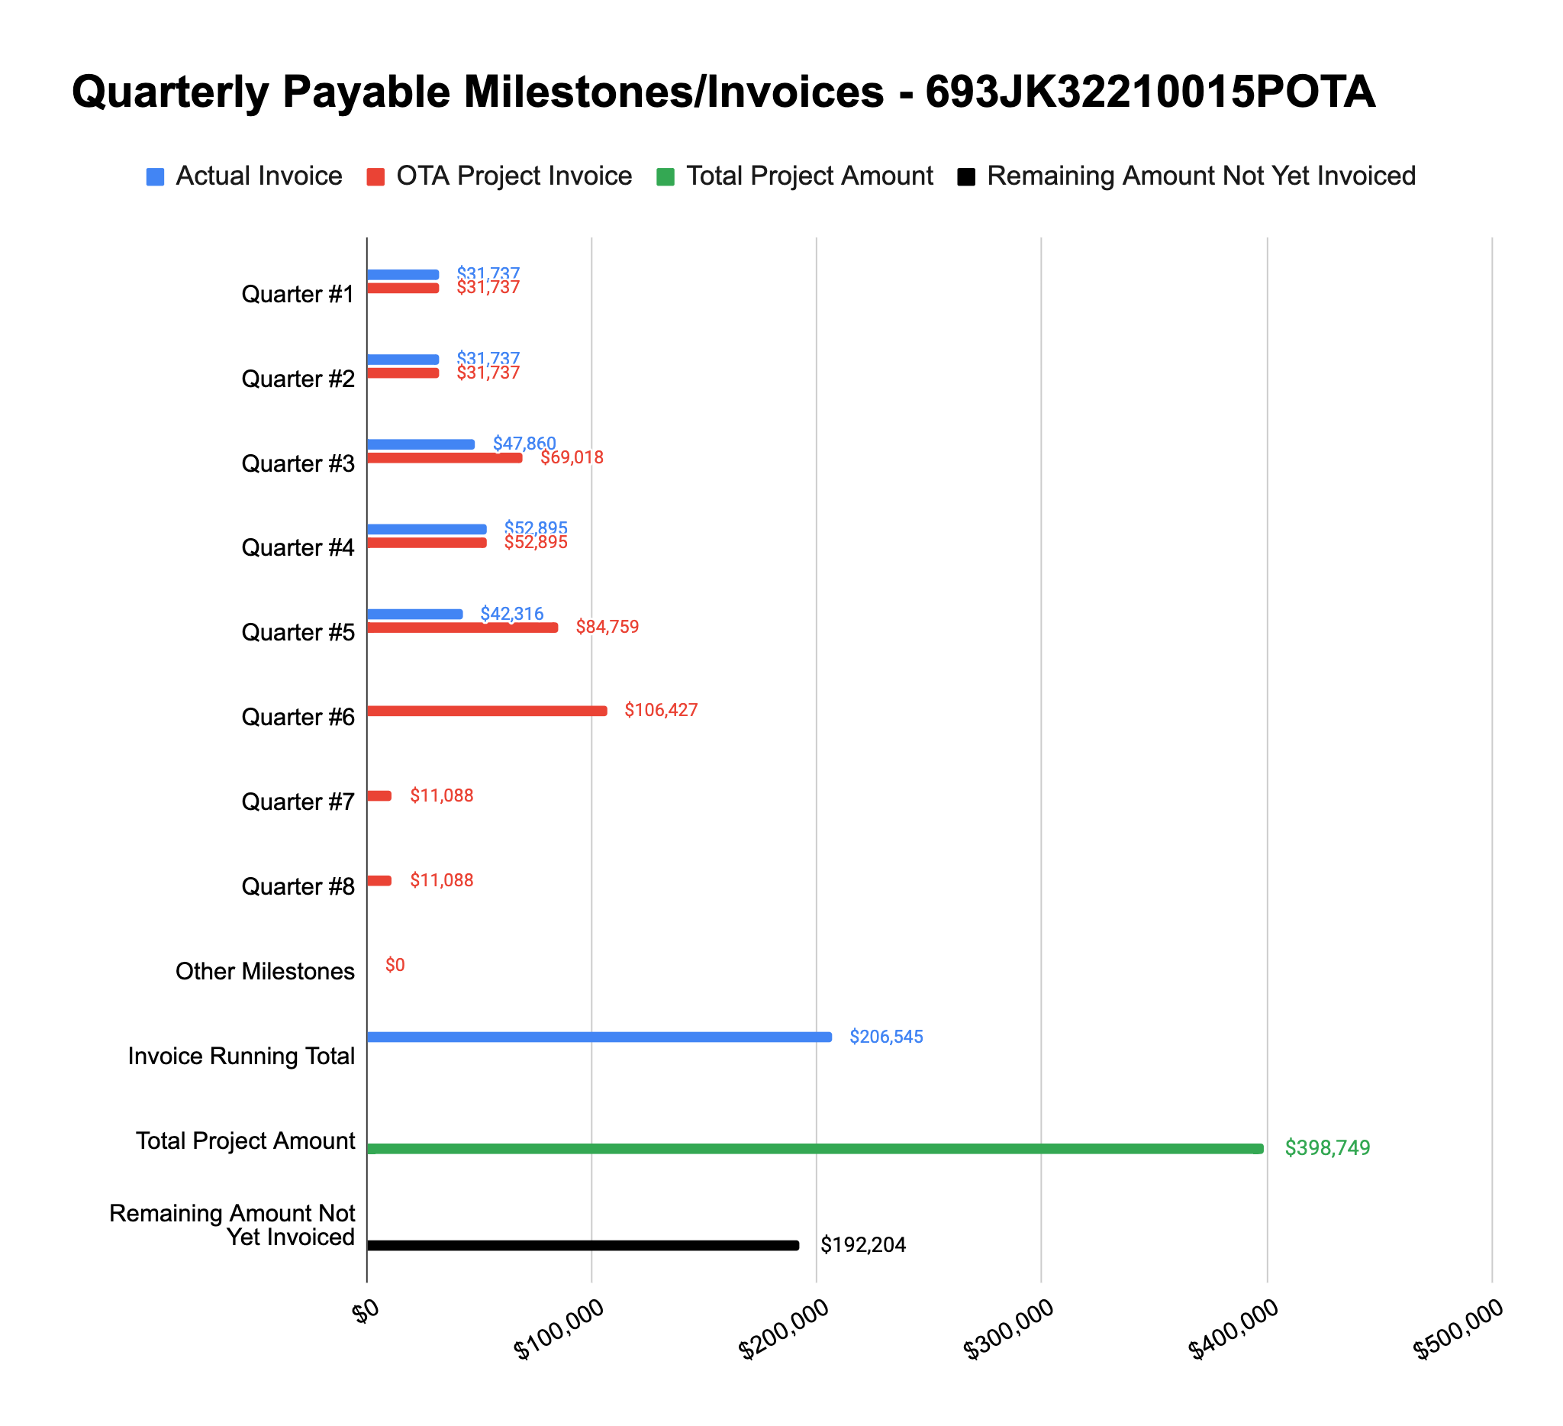

**4: Project Technical Status –**

**Item# 13 / Task# 3.2/ Geohazards Module / Post-process InSAR measurements for TAP operators asset base into geodatabase; Develop API wrapper for geohazard geodatabases**

Over the past quarter we’ve made considerable progress on this task. We have finalized the vector data file formatting for interferometric radar (InSAR) data such that it can be properly stored in a geodatabase and retrieved for load case creation. While this data is traditionally stored in raster format, we’ve developed our vector format to enable storage in a traditional geodatabase and make for easier workflows in performing geospatial analysis. Any InSAR processing done for a portion of or all of an operator's assets can be exported in this format and ingested into a Postgres or similar geodatabase.

As it relates to the API wrapper for translating and utilizing our geohazard geodatabases, over the past quarter we have enhanced our slope geohazard capability to include secondary data needed to drive the creation of load cases. In particular, for areas indicated at-risk for landslide, what the run-out direction and distance are. The remainder of the work left under this task is associated with adding an additional layer of data to our karst database. Currently that database maps out locations at risk of being exposed to a sinkhole but it excludes summary statistics needed to completely create the load case (namely the mean diameter and depth of the potential sinkhole). This summary data has been derived from various state and local surveys of sinkholes based upon the bedrock composition. The remaining work involves completion of the update to our existing sinkhole geodatabase with these size statistics. Given this work is low risk, we anticipate it being complete in the next few weeks.

**Item# 14 / Task# 3.3/ Geohazards Module / Submit Geohazards API and Methodology Documentation**

Over the past quarter we’ve made considerable progress on this task. Currently we have a working draft of this document and are working to add details for each geohazard type (seismic, landslide, sinkhole, and subsidence) - including the newer features associated with Task 3.1 and 3.2. This work is very low risk and should be complete over the next month.

**Item# 15 / Task# 4.1/ Load Case Module / Develop library to extract prior seismic event load case boundary conditions (acceleration loads) and ground kinematics conditions (subsidence loads)**

Over the past quarter we’ve made considerable progress on this task. Currently the codebase supports the extraction of geohazard loads associated with seismic and earth movement from geodatabases - this is done for each segment of the pipe network within the pipeline data model. The remaining work in-progress at the moment is completing a small python library which performs a coordinate frame transformation for the earth movement (subsidence) loads. The ground kinematics associated with earth movement (resolved by satellite radar interferometry) are in a geodetic frame (up, north, east) and must be converted into the local pipe segment frame so that the loads can be applied and stress estimated properly. This last piece, being low risk, should be complete in the next couple weeks and this task will be closed out.

**Item# 11 / Task# 5.2/ Cost Estimation Module / Research and create replacement/triage cost estimation framework; Cost estimation report generator module development**

Since our Q4 status report, we have completed all work associated with this task - including the creation of a report template as well as code development. The code development resulted in a library set for the cost estimation report generation using the cost methodologies and template - the output is a formatted PDF file. As discussed previously, the replacement cost algorithm builds off the work done in the backfill re-engineering methodology but also includes cost factors for pipe material and welding developed by the Pacific Northwest National Laboratory, which are also translated to current-year dollars using CPI data. The cost methodologies and algorithms are documented in detail in the Costing API and Methodology Documentation - which was uploaded to PRIMIS in early November.

**Item# 16 / Task# 5.3/ Cost Estimation Module / Develop costing API for rehab/replace/triage; Initialize storage database for client recommendation reports**

Since our Q4 status report, we have completed all work associated with this task. The bottoms-up cost methodologies and costing algorithms for both rehabilitation and replacement were implemented in python libraries. The libraries can be called to estimate the various cost categories and associated factors in current year dollars using CPI data. Also included in the python library is the report generator library, which takes the outputs from the cost estimations and creates PDF reports which can be stored in a database and later linked to the pipeline UPDM model.

**Item# 17 / Task# 5.4/ Cost Estimation Module / Submit Costing API and Methodology Documentation**

Since our Q4 status report, we have completed all work associated with this task. The deliverable was uploaded to PRIMIS on November 2nd.

**Item# 18 / Task# 6.1/ GIS Interface / ArcGIS interface initialization, geodatabase connections, and dashboard setup**

Over the past quarter we’ve made considerable progress on this task. Currently we have a sample UPDM model of a gas network which we have derived from the Esri-provided sample model. The interface between the tool and ArcGIS (and subsequent client UPDM) is done internally using ArcPy. All python code developed has been tested in this environment and allows for the initialization of the tool and subsequent workflows.

The remaining work for this task involves finalizing the connections to existing cloud-based, postgre geohazard geodatabases we have deployed - this effort should take less than a week to complete. Additionally, the other remaining work is associated with the visual design of the dashboard view within ArcGIS, which shows a summary view of the most recent tool run - this task is low risk and should be complete within about a month.

**Item# 19 / Task# 0.1/ 5th Quarterly Status Report / Submit 5th quarterly report**

Additional detail not necessary - this report constitutes the deliverable for Item# 19 / Task# 0.1.

**5: Project Schedule –**

Overall our project is about 3-4 weeks behind schedule. A key member of the team was out on paternity leave during the second half of this past quarter - something we had not accounted for when we proposed the original work plan. With that member now back, we expect to close that gap and get back on schedule over the next month or so.